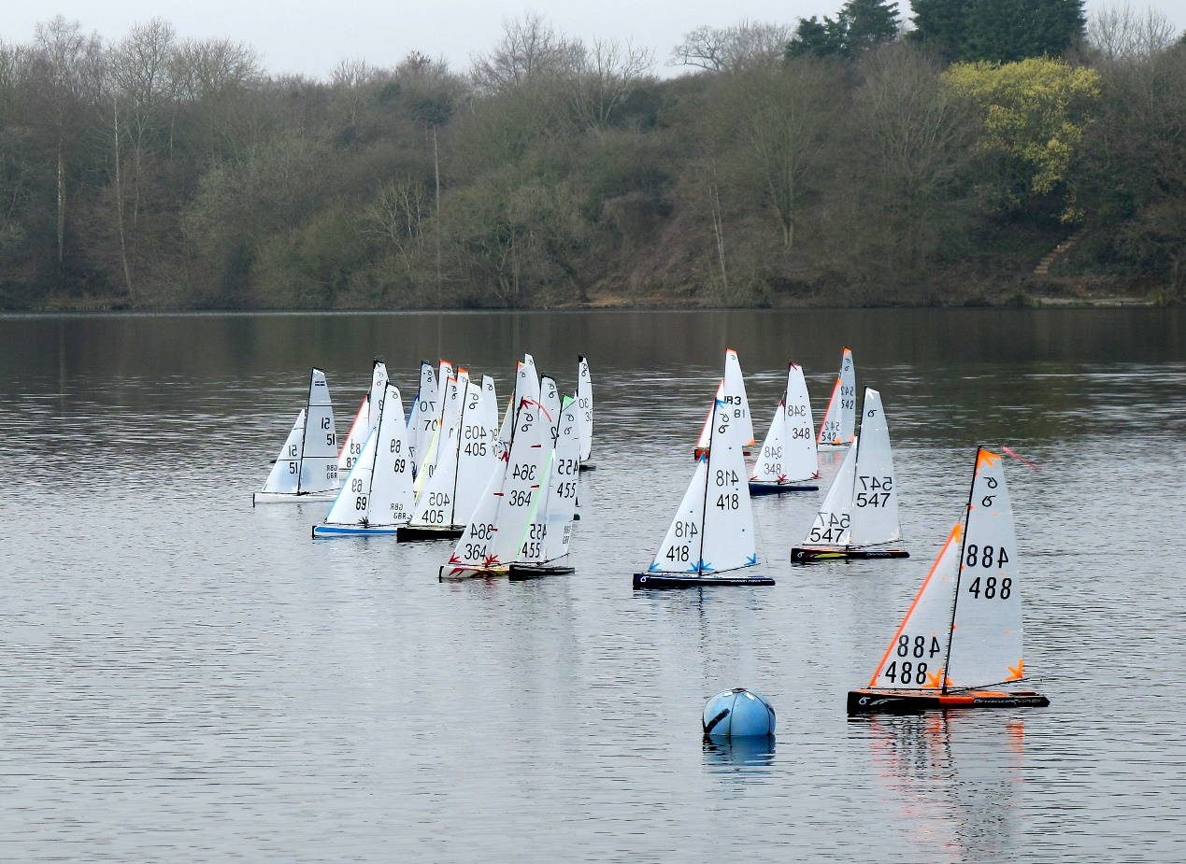

CHIPSTEAD SC RADIO SAILING SCHEDULE
FOR
2019

Winter Series 2019
January ,February and March
IOM Every Wednesday from: 10.00am Start
January 2^{n} – March 27th
Dragon Flite Every Monday from: 10.00am start
January 7th – March 25th
Any Class Free Sailing
Every Friday from January 4th – March 29th
Start around 10.30am lunch 12.30pm
Finish around 2.00pm
This is an ideal time for learners to practise and /or anybody to tune their yachts in readiness for the series race the following week
There will be a work party on Saturday 2nd February 10.00am Start. “ It is essential that all attend as we all use the equipment we should all be involved in maintaining the buoys boat engine jetty’s etc. there will be jobs for all.”

Spring Series 2019
April
May
June
IOM Every Wednesday from: 10.00am Start
April 3rd -June 26th
Dragon Flite Every Monday from: 10.00am start
April 1st^{rd} –June 24th
Any Class Free Sailing
This is an ideal time for learners to practise and /or anybody to tune their yachts in readiness for the series race the following week

Every Friday from April 5th –June 28th
Start around 10.30am lunch 12.30pm
Finish around 2.00pm

Summer Series 2019
July
August
September
IOM Every Wednesday from: 10.00am Start
July 3rd-September 25th
Dragon Flite Every Monday from: 10.00am start
July 1st- September 30th
Any Class Free Sailing
Every Friday from July 5th – September 27th
Start around 10.30am lunch 12.30pm
Finish around 2.00pm
This is an ideal time for learners to practise and /or anybody to tune their yachts in readiness for the series race the following week

Autumn Series 2019

IOM Every Wednesday from: 10.00am Start
October 2nd - December 18th
Dragon Flite Every Monday from: 10.00am start
October 7th - December 23rd
Any Class Free Sailing
Every Friday from October 4th – December 27th
(Excluding Xmas week)
Start around 10.30am lunch 12.30pm
Finish around 2.00pm
This is an ideal time for learners to practise and /or anybody to tune their yachts in readiness for the series race the following week

Open Events and Trophy races during 2019
Open Marblehead Event
Saturday 19th January 10.00am start
IOM Open Unicorn Trophy Race
Sunday 10th February 10.00am start
Dragon Flite Open Invicta Trophy Race
Saturday 9th March start 10.00am Start.
Club Events 2019
IOM Bullard Trophy
Wednesday 26th June 10.00am start
Dragon Force Peter Curl Trophy
Monday 1st July Start time 10.00am
IOM Memorial Race
Wednesday 9th October Start time 10.00am
This is a handicap race but will also be included in the overall October results for winter series
Dragon Force Memorial Race
Monday 7th October Start time 10.00am
This is a handicap race but will also be included in the overall October results for winter series

All competitors should bring the necessary certificates ect to be presented at check in. All these races start at 10.00am but competitors should be there for the pre race talk at 9.30amThere will be drinks and meals available at the lunch break for all, there will be a small charge for this payable on the day. For further information the notice of race will be sent out nearer the time.

