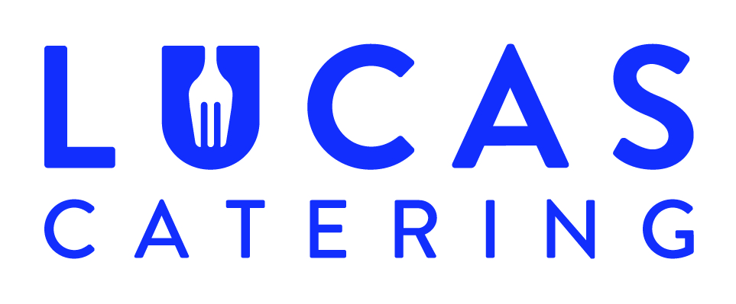

Where possible, all our products are homemade by our team of chefs in our production kitchen using local, fresh ingredients.

Chipstead Sailing Club Xmas Lunch
2018

Starters
Curried Parsnip Soup (V)
Chicken Liver Pate with Onion Chutney
Fried Haloumi with Sweet Chilli Dip (V)

Mains
Roast Turkey and stuffing with chipolatas, roast potatoes, roast parsnips, sprouts, cauliflower cheese and Yorkshire pudding
Herb and shallot nut roast with above trimmings (V)
Mushroom and Spinach Risotto topped with Shaved Parmesan and Rocket (V)

Deserts
Xmas pudding with brandy sauce
Ice cream Selection
Chocolate Sponge and Crème Anglaise

Our dishes may contain traces of nuts
All allergen information for our dishes is available on request

